Delivering trusted water services for a sustainable and healthy South Australia
Position title | Water Security Analyst (Regional)
Business Group | Science and Strategy | People leader | Manager, Regional Water Security
Business Unit | Water Futures and Security | Direct report(s) | N/A

Purpose
Leveraging our groundwater data, together with other relevant regional water security data, to deliver advanced analytics that enable data-driven water security surveillance, compliance, advice, reporting and decisions in terms of SA Water’s regional South Australian:
• water supply infrastructure operations/planning/investment,
• groundwater resource condition management, and
• groundwater license compliance.

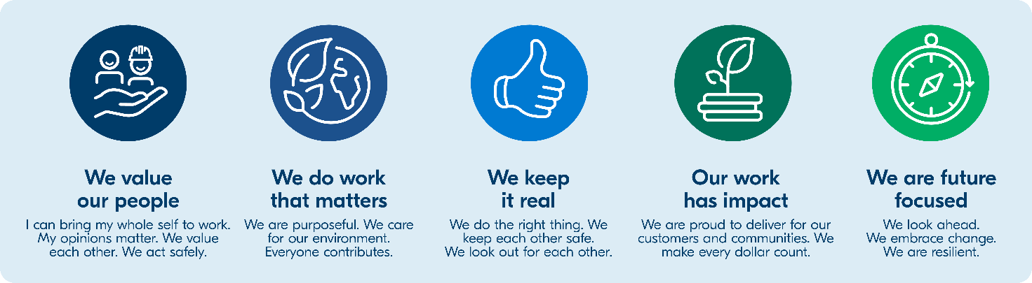
Our Values

Key accountabilities
Success in this role will be evaluated on the following key accountabilities:
Key accountabilities | Accountability details
Data & analytics to inform water security surveillance, compliance, advice, reporting and decisions | - Analysing regional SA water data to monitor risks, identify trends, develop dashboards/infographics for decision-makers, and develop predictive models for water availability.  - Drawing upon trusted data analytics to maintain compliance with water license reporting obligations, together with relevant internal water security reporting (e.g. water security risk status and Executive KPI reporting).  - Utilising AI tools to predict potential regional SA water security issues, such as supply shortages, infrastructure failures, or contamination events.  - Contributing to the development of AI-powered solutions to improve regional SA water supply systems and efficiency.  - Providing timely and actionable insights to help SA Water and our owner (the SA Government) to shape regional SA water security strategies, ensuring sustainable water supplies.  - Working with interdisciplinary teams (with SA Water and at DEW) to monitor groundwater quality and quantity, maintain trusted data, and maintain an Enterprise-supported approach to the functions of this role.
Contribute to achieving a high performing leadership team and delivering on team outcomes | - Contribute to a constructive, collaborative and supportive team environment that promotes SA Water’s values and desired behaviours (both within SA Water and inter-organisational working groups).  - Maintain timely and thorough administrative practices (aligned with corporate policies and systems) to ensure the professional management of corporate data, delivery of initiatives and the capture of corporate knowledge.  - Perform other reasonable duties as directed to help deliver team outcomes and manage workload across the wider team.  - Model SA Water’s values and set a positive professional example for our people across the business.  - Ensure the safety of our people, our customers and communities when engaging, by understanding and following appropriate safety processes and practical safety measures such as the use of travel plans and personal protective equipment.

Skills, knowledge, experience, behaviours, and attitudes
Key selection criteria:
Specialist skills/knowledge, qualifications, licences and/or tickets, and/or equivalent experience, attitudes and/or behaviours critical to the success of this role | Essential/Desirable
Data Analysis & Artifical Intelligence (AI)/Machine Learning (ML): Proficiency in data analysis, predictive modelling, and AI tools | Essential
Environmental/Water Science: Knowledge of water resources management, particularly groundwater | Essential
Technology Proficiency: Knowledge of SCADA, PowerBI, Azure/Cloud systems, AEM, satellite monitoring, IoT sensors, etc | Essential
Communication: Ability to communicate complex technical information to diverse stakeholders to aid decision-making | Essential
Relevant science, engineering or related qualifications and/or industry knowledge, and understanding of relevant technical, regulatory and policy requirements. | Essential
Well-developed organisational skills, including the ability to prioritise and multi-task. | Essential
Experience working in the field to gather groundwater data and/or install groundwater data collection instrumentation | Desirable
Knowledge of the functions of SA Water in Regional SA | Desirable
Knowledge of the governance of water resources in Regional SA (i.e. the respective roles of DEW and Landscape Boards, relative to SA Water) | Desirable
Excellent stakeholder management skills, including a demonstrated ability to work with internal and external stakeholders, effect long lasting relationships, and drive mutually acceptable outcomes. | Desirable
Ability to draw conclusions and to make recommendations on the basis of data analysis, research and engagement. | Desirable
Excellent written and verbal communication skills and an ability to clearly articulate messages to a variety of audiences | Desirable

Key stakeholder relationships
Key stakeholder relationships critical to the success of this role:
- Water Futures and Security Team.
- SA Water technical working groups.
- Key external stakeholders.

Special conditions
- Flexible hours and some after hours as required.
- To ensure your safety in performing the inherent requirements of the role, you will be required to undergo initial and subsequent medical clearances in addition to some immunisations as relevant to your position.
- Depending on the role you will be required to undergo initial and/or subsequent clearance checks to ensure your ongoing suitability for the role. These may include a criminal police check, traffic check, Working with Children and/or Working with Vulnerable People checks.
- Some intra and/or interstate travel.
The Position Description outlines what the requirements of the role are. The behaviours you demonstrate are equally as important, and form part of the inherent requirements of the role.

